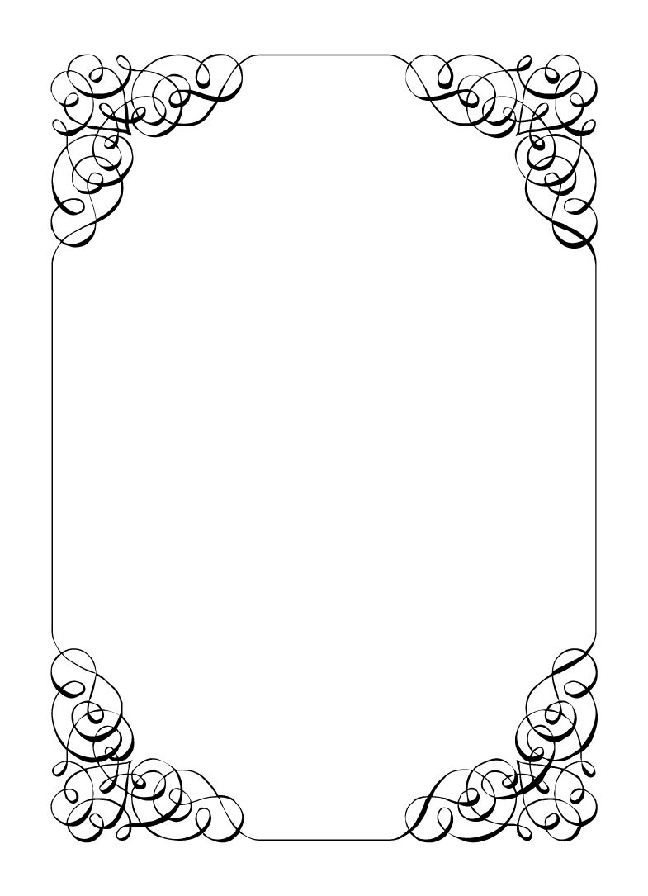

Not here to wed spiders

Malibu Singer

*In the small town of Duck Rise, Victoria, Stralya live: BOGANS. Bogans are much like the regular folk, but drunker and louder. Some of them even fall in love. But before they settle down and poop out a mess of kids, they gotta have a wedding! Weddings are the best. Everyone gets proper plastered. Lots of kissing. Lots of drama. Fun times for all. Nothing ever goes wrong at a wedding...*  
*\*\*ominous thunder clack\*\**

Malibu Singer

Wedding Planner *Clumsy, Good hearted, Nervous*

The whole world seems to be against you. You are always so kind, but *gosh*, things just never seem to go your way. 😢.  
Maybe today is the day everything turns around? Yeah... maybe everything is coming up Malibu! 😁  
  
Last Night: You had a great time at the bachelor party. Dave, Wayne, Chad, Sparkie, and Lucky were there. You kidnapped Chad, went on a HUGE pub crawl, then went to the casino for a few hours. At the casino you shooed Lucky the Wonder Dog away from the trash out front, where you spotted a ring box with two BIG rings.  
  
You pocketed the rings, and proceeded to have a grand time at the casino, meeting a local lass. You took her back to the hotel that night and stayed in your room. Just like usual, you cried afterwards and she left a little confused.  
  
Upon arriving at the wedding you hid the rings in the wedding cake for safe keeping. Whomever cuts the cake will probably find them.

**Goals**

* **Officiate this shingdig:** If you are the marriage boss, you can just fake the paperwork and it wont count! Make a long speech about 'real love' like you and Corolla have but don't embarrass her by mentioning her name.
* **Stay married to Corolla:** Steal some private moments alone with her. Maybe she will remember the good old days.
* **Sparkie needs a hand:** Sparkie needs help getting down the aisle with his daughter. Make sure he stays upright for the whole thing.
* **Ring a ding ding:** Be the one to cut the cake and pocket the ring until the ceremony.
* **Catch the bouquet:** If you catch it, your whole life will turn around. You can feel it.

**Other People**

**Chad Marolla**

You can't believe Chad is trying to steal Corolla away, so what if he benches 200kg? He couldn't hold up 1 minute of conversation.

**Corolla Castro**

The love of your life. You are even already married! If you can just make her see that...

**Gemini Belmont**

Corolla's best friend, you have heard they are a steadfast bad ass, but have never met.

**Mercedes Bennie**

Corolla's foster sister. She was always stomping around the house in a huff when you visited.

**Dave Torana**

You really connected with Dave last night at the bachelor party. You needed a distraction and he certainly knows how to party.

**Sparkie Castro**

You've always had a good relationship with Sparkie, whenever you visited Corolla you would chat but he has become less talkative since Corolla's engagement.

**Vectra Marolla**

She's so controlling that she might turn Corolla off Chad. What a nightmare.

**Lucky the Wonder Dog**

This dog is better behaved than some of the groom's family. Lucky has such intelligent eyes, you often feel like they are trying to tell you something.

**Abilities**

Use these to do things. They have a limited use, so check them off when you use them.

|  |  |
| --- | --- |
| Ability | I'm too busy |
| If someone uses an ability on you that forces you to reveal your information or secret, show this ability to them and keep your information or secret hidden instead. |
| Usages: O O O |

|  |  |
| --- | --- |
| Ability | I'll let you in on a secret |
| Show someone your 'Other People' section about them (this ability does not work on players not in your Other people section). If you manage this, the player must show you their secret. |
| Usages: O O O |

|  |  |
| --- | --- |
| Ability | SHHHHH!! |
| Scold someone for ruining the atmosphere you have carefully created. If you manage this, the player must show you their other people section for the character of your choice. |
| Usages: O O O |

|  |  |
| --- | --- |
| Ability | Legal paperwork |
| You can draw up any legally binding contract for anyone. (Ask an Organiser for help) |
| Usages: Special |

**Secret and Information**

Your Secret contains your guilty secret, while your Information contains one or more items of information you know. Both may be affected by abilities. Your lie may need to be filled out later.

While you can show your Secret and Information to whomever you like, you will probably not want to reveal your Secret too often. (Please note that you can’t solve the crime by looking at everyone’s Secret and Information – it’s not that easy!)

|  |  |
| --- | --- |
| Secret | You are already married to the Bride. |

|  |  |
| --- | --- |
| Information | You got a one night stand at the last pub and brought them back to the hotel. From the banging on the walls it sounded like everyone else got lucky too. |

**The Organiser’s Word is Law:** The organisers are impartial. If you have a problem or want to do something unusual, see an organiser. The organiser’s power is absolute – and cannot be affected by ability cards!

**Winning and Losing:** You can achieve most of your goals simply by talking to people. The organisers will announce when the game is over. If you haven’t succeeded by that point – you’re too late! Be warned – not everyone here will want you to succeed!

**Doing Stuff:** Ordinary actions are resolved by simply carrying them out. If you want to try something unusual (such as trying to hack the pentagon), see an organiser. The organisers knows everything – and will be able to tell you the outcome of whatever it is that you are trying to do. (For example, you are trying to hack over state lines and you are caught.) Do use your imagination, though! – this is a very flexible game, and you can do all sorts of things beyond what’s listed in these rules.

**Fighting:** If an ability or item lets you hard another player, don’t just dive in! See the organisers first and tell them what you plan to do so they can oversee and give you more detailed rules if it’s necessary.

**Leaving:** You cannot leave, it is rude to leave a wedding and you are in the middle of nowhere!

**Role Cards:** If someone asks you for your role in the wedding ceremony, and you have one, you must show them all your roles.

**Item Cards:** Any items of importance within the game are represented as Item cards – and the only items that can affect the game are those detailed on the cards. If you do not have an Item card, you do not have that item with you.

**Time:** This game is played over three (ish) hours, including time for reading your character etc. There will be breaks throughout the evening! The organisers will tell you when each period starts and finishes.

**Character List**

**Chad Marolla – *Groom***

The soon to be husband. A bit nervous about the wedding, but is letting Corolla take care of the hard stuff.

**Corolla Castro – *Bride***

She knows what kind of wedding she wants, and that's the kind of wedding we are having! NO EXCEPTIONS!

**Gemini Belmont – *Maid of Honour***

She carries herself like she just escaped a warzone. Maybe she did? She's real quiet and might throat punch you if you ask stupid questions.

**Mercedes Bennie – *Flowergirl***

She's 12 but everyone knows better than to treat her like a 12 year old. Punk AF and will burn this all down on a whim.

**Robin Smith – *Priest***

Not from here. Better than everyone else (or at least thinks so).

**Dave Torana – *Best Man***

Childhood friends with the Groom. He was the smooth talking hottie that picked up enough for both of them. But that part of his life is over now.

**Malibu Singer – *Wedding Planner***

For a professional organiser, not very organised. Has just managed to keep everything running so far.

**Sparkie Castro – *Bride's Father***

He's been waiting his whole life for this moment. His baby girl is finally gonna get married and he knows just how to get through the day without crying...

**Vectra Marolla – *Groom's Mother***

The Queen that runs this town. Knows where the bodies are buried, but will never tell. Everyone respects her.

**Wayne Marolla – *Drunk Uncle***

He's maybe had a few too many. Started stumbling around and saying weird things. Every wedding has one.

**Lucky the Wonder Dog – *Dog***

A good dog. *bark* *bark* "What's that Lucky? You want pats?"

**Mungo Joint – *Photographer***

Seems like they are creeping on everyone, but they were hired to take wedding photos so it's probably fine.